# File permissions and manipulation in Linux

## Project description

The research team of my organization needs an update to the directories and files within the project’s directory. Updating the permissions for the appropriate authorization will ensure the security of the system. Following tasks:

## Check file and directory details

The following code demonstrates how I used Linux commands to determine the permissions through the directory

## Describe the permissions

The organization determined that group and other should not be able to read any of the project_r.txt file, as well as giving permission to execute to the user. After they considered to hide the file. The second decision was to make the hidden file .project_x.txt unhidden as well as only readable to user, group and other. To comply with this used the chmod command so i could deny the permission to read.

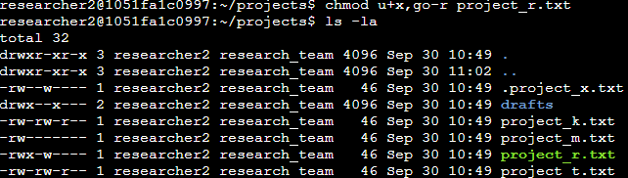

## Change file to hidden

After successfully changing the permission I uses the mv command to convert the project_r.txt file to hidden .project_r.txt, where dot (.) describes hidden files. In the process I use the ls -la so I can confirm my changes.

## Change file permissions on a hidden file

As it follows my next step was to change the permission to write and read of the already existing .project_x.txt hidden file. The chmod u-w,g-w,go+r .project_x.txt is a short command where u -> users , g -> group and o -> other and w ->write, r->read and x ->execute.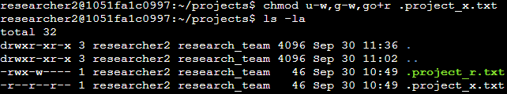

## Change hidden file

My last action was to move the file from hidden to unhidden .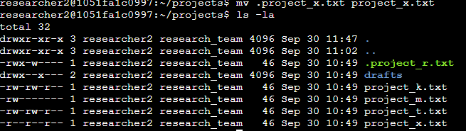

## Summary

I change multiple permissions as well as file to much the needs of the organizations wanted files and directories to match the level of authorization in the project directory. I use the following commands: pwd , cd, ls ,ls -la ,mv, chmod.